# Appendix A1

Additional information on the parameterization process of the FORMIND forest model including management-module and detailed lists of the parameter values used are documented below. For a more detailed model description see (Fischer et al., 2016) or on the homepage www.FORMIND.org.

## A1.1 The model's parameterization

**The model landscape** is defined as squared area from 1ha up to several km2 (in this study 16ha) being composed of such squared patches (Figure A1).

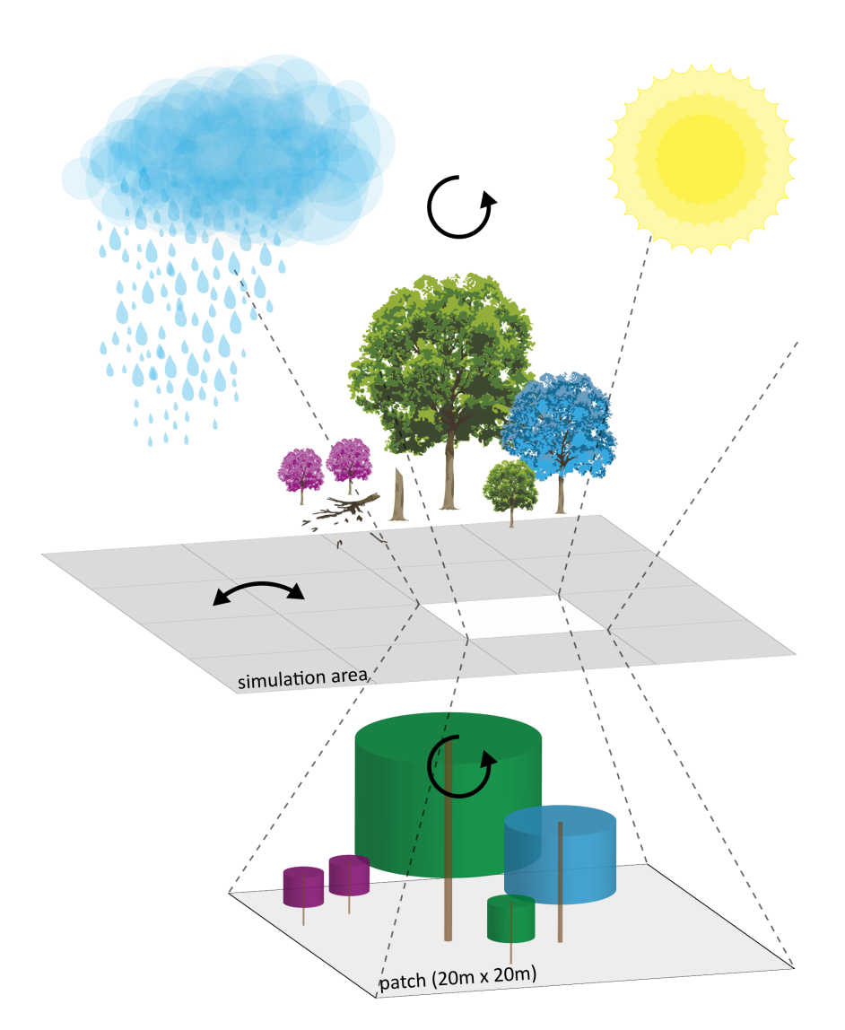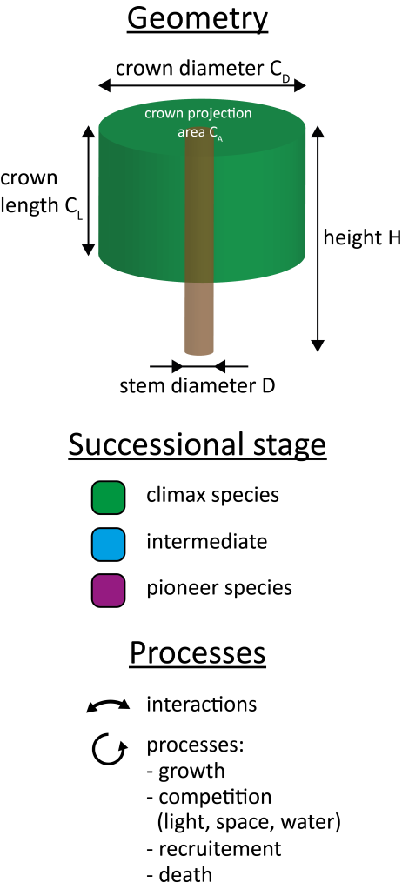

Figure A1: The forest model FORMIND is a gap model. The simulation area consists of at least 1ha (16ha in this study) squared patches of 20m by 20m. Patches obtain an explicit spatial position, while the trees within a patch are positioned explicitly depending on the light climate on the ground. It is individual-based and on the basis of field measurements each tree is modeled, and then summed up on stand level. Since tropical forests are species-rich, tree species are grouped into plant functional types PFT according to functional traits, such as succession states. The four main processes considered are tree growth, completion for light, space, recruitment, and mortality (Fischer et al., 2016).

**Allometric relations of the trees** were modeled on a tree-level for stem diameter measurements at breast height DBH. Undetermined tree species were gathered and their parameter values were averaged. Since wood density is related to the forest stand dynamics, we assigned all available wood densities after Chave et al. (2009) and Zanne et al. (2009) to the tree species and completed undetermined ones by deriving mean wood densities that were genre-, family- or study site-specific. All derived geometric relations were then aggregated group-specifically to model tree growth individually (Figure A2). The functional relations of tree geometry used are documented in Table A1 and the parameter values can be found in Table A2. Throughout the study corrected values of DBH measurements were used (see Appendix A1.2).

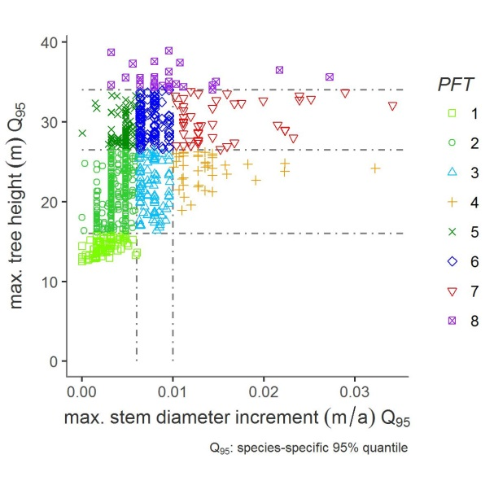

Figure A2: Grouping of circa 700 tree species (dots) into eight plant functional types PFT according to the 95%-quantiles of maximum stem diameter increment and potential tree height per tree species. The dashed lines indicate the class limits of grouping conditions.

Table A1: Functional relations used in this study with *agb*: aboveground biomass; *cd*: crown diameter; *circ*: stem circumference; *cl*: crown length; *DBH*: stem diameter at breast height; *dinc*: stem diameter increment; *f*: form factor; *h*: growth height; *lai*: leaf area index; *m*: stem based mortality rate; $ρ$: wood density; *tr*: fraction of stem biomass to total aboveground biomass. Further basic functions are listed in Fischer et al. (2016).

|  |  |
| --- | --- |
| **Geometric relation** | **Function** |
| stem circumference-DBH | $$dbh(circ)=circ/π$$ |
| aboveground biomass-DBH | $$agb(dbh)=π/4*ρ/tr*dbh^{2}*h*f$$ |
| crown diameter-DBH | $$cd(dbh)=cd_{0}*dbh^{cd_{1}}$$ |
| crown length-height | $$cl(h)=cl_{0}*h$$ |
| stem diameter increment-DBH | $$dinc(dbh)=a_{0}*dbh*(1-dbh/dbh_{max})*exp(-a_{1}*dbh)$$ |
| form factor-DBH | $$f(dbh)=f_{0}*dbh^{f_{1}}$$ |
| tree height-DBH | $$h(dbh)=h_{0}*dbh/(h_{1}+dbh)$$ |
| leaf area index-DBH | $$lai(dbh)=l_{0}*dbh^{l_{1}}$$ |
| mortality-DBH | $$m(dbh)=m_{0}*e^{-m_{1}*dbh}$$ |

Table A2: PFT-specific parameter values and their meaning or unit of the forest model FORMIND used for the Paracou test site.

|  |  |  |  |  |  |  |  |  |  |  |  |
| --- | --- | --- | --- | --- | --- | --- | --- | --- | --- | --- | --- |
| **Parameter** | **Description** | **Unit** | **PFT1** | **PFT2** | **PFT3** | **PFT4** | **PFT5** | **PFT6** | **PFT7** | **PFT8** | **Reference** |
| **Light and establishment** | | | | | | | | | | | |
| k | light extinction coefficient | - | 0.7 | 0.7 | 0.7 | 0.7 | 0.7 | 0.7 | 0.7 | 0.7 | (Köhler et al., 2003) |
| nseed | global number of seeds | 1 ha-1 | 2 | 27 | 2 | 15 | 14 | 16 | 20 | 2 | fine-tuned |
| iseed | Minimum light intensity to establish | - | 0.01 | 0.01 | 0.05 | 0.20 | 0.01 | 0.02 | 0.15 | 0.01 | (Köhler et al., 2003) |
| **Geometry** | | | | | | | | | | | |
| hmax | maximum growth height | m | 16.50 | 34.22 | 34.61 | 34.85 | 40.40 | 39.96 | 38.58 | 39.06 | derived from inventory data |
| h0 | height-DBH-relation | - | 47.0 | 47.0 | 47.0 | 47.0 | 47.0 | 47.0 | 47.0 | 47.0 | Calculated from (Molto et al., 2014a, 2014b) |
| h1 | height-DBH-relation | - | 0.276 | 0.276 | 0.276 | 0.276 | 0.276 | 0.276 | 0.276 | 0.276 | Calculated from (Molto et al., 2014a, 2014b) |
| cd0 | crown diameter-DBH-relation | - | 13.12 | 13.12 | 13.12 | 13.12 | 13.12 | 13.12 | 13.12 | 13.12 | calculated from (Jucker et al., 2017) |
| cd1 | crown diameter-DBH-relation | - | 0.59 | 0.59 | 0.59 | 0.59 | 0.59 | 0.59 | 0.59 | 0.59 | calculated from (Jucker et al., 2017) |
| l0 | lai-DBH-relation | - | 2.0 | 2.0 | 2.0 | 2.0 | 2.0 | 2.0 | 2.0 | 2.0 | (Köhler et al., 2003) |
| l1 | lai-DBH-relation | - | 0.0 | 0.0 | 0.0 | 0.0 | 0.0 | 0.0 | 0.0 | 0.0 | (Köhler et al., 2003) |
| f0 | form factor-DBH-relation | - | 0.425 | 0.425 | 0.425 | 0.425 | 0.425 | 0.425 | 0.425 | 0.425 | derived from inventory data |
| f1 | form factor-DBH-relation | - | -0.18 | -0.18 | -0.18 | -0.18 | -0.18 | -0.18 | -0.18 | -0.18 | (Fischer et al., 2014) |
| cl0 | crown length factor-height-relation | - | 0.358 | 0.358 | 0.358 | 0.358 | 0.358 | 0.358 | 0.358 | 0.358 | (Köhler et al., 2003) |
| σ | fraction of stem biomass-total biomass | - | 0.7 | 0.7 | 0.7 | 0.7 | 0.7 | 0.7 | 0.7 | 0.7 | Derived from inventory data, fine-tuned after (Rutishauser et al., 2010) |
| **Biomass and productivity** | | | | | | | | | | | |
| ρ | wood density | $$t*m^{-1}$$ | 0.76 | 0.77 | 0.66 | 0.55 | 0.83 | 0.73 | 0.56 | 0.62 | calculated from (Chave et al., 2009; Zanne et al., 2009) |
| M | transmission coefficient of leafs | - | 0.1 | 0.1 | 0.1 | 0.1 | 0.1 | 0.1 | 0.1 | 0.1 | (Larcher, 1994) |
| G | gross productivity to respiratory costs | - | 0.2 | 0.2 | 0.2 | 0.2 | 0.2 | 0.2 | 0.2 | 0.2 | fine-tuned |
| α | slope of light response curve | $$μmol_{CO_{2}}*μmol_{photons}^{-1}$$ | 0.043 | 0.043 | 0.035 | 0.086 | 0.043 | 0.043 | 0.086 | 0.043 | (Köhler et al., 2003) |
| pmax | maximum leaf photosynthesis | $$μmol_{CO_{2}}*(m^{2}*s)^{-1}$$ | 1.12 | 0.55 | 2.00 | 20.59 | 1.35 | 1.50 | 27.00 | 1.46 | fine-tuned |
| gmax | maximum annual stem diameter increment | m/a | 0.011 | 0.018 | 0.017 | 0.014 | 0.025 | 0.013 | 0.022 | 0.031 | derived from inventory data, fine-tuned |
| gDBHmax | maximum stem diameter | - | 0.24 | 0.17 | 0.12 | 0.11 | 0.30 | 0.11 | 0.17 | 0.37 | derived from inventory data, fine-tuned |
| **Mortality** | | | | | | | | | | | |
| mmean | background mortality rate | - | 0.01 | 0.01 | 0.013 | 0.02 | 0.01 | 0.01 | 0.02 | 0.01 | derived from inventory data |
| fallP | probability of dead tree to fall | - | 0.5 | 0.5 | 0.5 | 0.5 | 0.5 | 0.5 | 0.5 | 0.5 | derived from inventory data |
| **Management- module** | | | | | | | | | | | |
| commspec | proportion of commercially logged species | - | 0.0 | 0.0362 | 0.2393 | 0.0865 | 0.5718 | 0.5531 | 0.3311 | 0.2706 | derived from inventory data |
| logDBH | DBH lower cutting threshold | m | 0.55 | 0.55 | 0.55 | 0.55 | 0.55 | 0.55 | 0.55 | 0.55 | derived from inventory data |

**Calibration and fine-tuning:** The parameters describing the photosynthesis (*pmax*), the slope of the light response curve ($α$), the maximum stem diameter growth rates (*gmax, gDBHmax*), and the number of seeds (*Nseed*) are important for the succession of the forest stand and the composition of the tree species. These parameters were numerically calibrated and fine-tuned using the dynamically dimensioned search *DDS* (Lehmann and Huth, 2015). The simulation results of the model (aboveground biomass, stem number, basal area) were calibrated using aggregated criteria derived from Paracou's forest inventory data of the T0-control plots (Figure A6). The Paracou data represent a forest at its equilibrium state. The *DDS* method ran with $1.0*{10}^{6}$ iterations and a search radius of 0.2. The cost function computed the standard error *Q* between the observed *o* and modeled *m* values as follows:

$$Q=Q_{B}+Q_{N}=\sum_{p}{(}ω_{Bp}*|Q_{Bp}|)+\sum_{p}{(}\sum_{d}{(}ω_{Dd}*|Q_{Nd}|)*ω_{Bp})=\sum_{p}{(}B_{op}/B_{ot}*|(B_{mp}-B_{op})/B_{op}|+\sum_{p}{(}\sum_{d}{(}D_{d}/D_{t}*|(N_{md}-N_{od})/N_{od}|)*B_{op}/B_{ot})$$

with *QB* and *QN* as weighted relative errors and the indices representing the aboveground biomass *B* and stem numbers *N*. *QB* and *QN* equal the sums over all absolute values of their relative errors multiplied with weighing factors $ω$. The relative errors between the observed *o* and modeled *m* values of *B* or *N* were calculated either for each plant functional type *p* or each stem diameter class *d* (class width = 0.1 m). The weights $ω_{Bp}$ and $ω_{Dd}$ were determined regarding either the *PFT*'s observed aboveground biomasses or the mean stem numbers *D* per stem diameter class *d* as fraction of their total sums *t*. The weighting of the *PFT*'s aboveground biomasses and the stem numbers should ensure that the model output, necessary for answering the research questions, was modeled precisely. Decisive for the quality of the cost function were the appropriateness of the weighting factors $ω$. This led to the fact that the aboveground biomass of more dominant *PFT*s and the frequency of tall trees with a large stem diameter had a greater impact on the simulation result during the parameter set's fine-tuning. Ranges of the fine-tuned parameters are shown in Table A3.

The values for *pmax* and *nseed* are based on knowledge from previous studies (Fischer et al., 2014; Hiltner et al., 2016; Köhler et al., 2003). It was important that the calibrated parameters did not reach the upper or lower limits. All parameter values used in the parameterization of the FORMIND forest model are documented in Table A2.

Table A3: Model calibration and fine-tuning. PFT-specific ranges of the parameter values that were fine-tuned using the dynamically dimensioned search DDS (Lehmann and Huth, 2015).

|  |  |  |
| --- | --- | --- |
| **PFT** | **Range of nseed** | **Range of pmax** |
| 1 | [1; 10] | [0.9; 3.0] |
| 2 | [1; 35] | [0.4; 3.0] |
| 3 | [1; 60] | [3.0; 10.0] |
| 4 | [15; 100] | [10.0; 25.0] |
| 5 | [1; 25] | [0.9; 3.0] |
| 6 | [1; 60] | [3.0; 10.0] |
| 7 | [15; 100] | [10.0; 28.0] |
| 8 | [1; 25] | [0.9; 3.0] |

Due to this approach, the forest model of FORMIND was calibrated against 136 data points originating from the forest inventories: taking eight *PFT*s by stem numbers of 16 stem diameter classes and their aboveground biomass of the cost function. Extensive preliminary testing of cost functions showed that the chosen criteria were the most effective within this study. Table A3 shows the results of the fine-tuning by presenting the total forest stand's tree size distribution. For trees with a *DBH* smaller than 0.4 m, the number of trees was slightly overestimated by the model, whereas the number of larger trees was very well recorded.

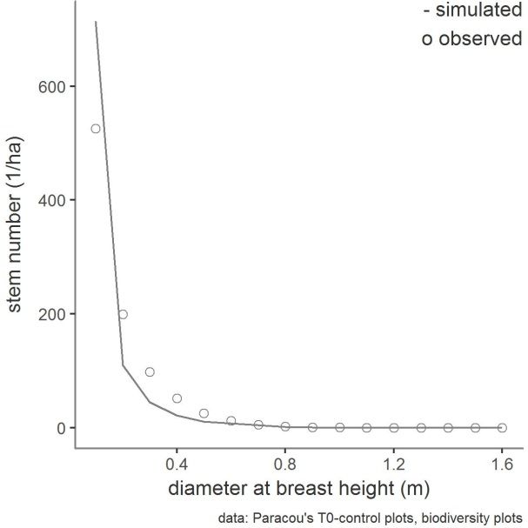

Figure A3: Model calibration: Comparison of the simulated and observed mean tree-size distribution of the entire forest stand. The mean values of the observations were calculated from the forest inventory data of the T0-control plots and biodiversity plot (cf. A1.2.1) of the period 1984-2016. The simulated mean values were averaged over 16 ha and over the years 333-1000, assuming that the forest was in equilibrium of a mature forest.

**Results of model calibration:** Figure A4 depicts the calibration results for the aboveground biomass and basal area. It can be seen that both the observed and simulated attribute values are affected by a certain variability represented by the standard deviation. The reason for this is that the data basis was subject to stochasticity, which is inherent in the natural dynamics of growth processes. Firstly, we compared the observed and simulated attribute values of the aboveground biomass over time in order to evaluate the succession dynamics of the individual species groups (Figure A4.a). Only simulation results of the equilibrium phase of the forest stand were taken into account (simulated time > 333 a). The simulated succession of the aboveground biomass per PFT was consistent. At the beginning of the simulation time, the fast-growing pioneer species and, most recently, the slow-growing climate species first established themselves on the treeless area; the intermediary PFTs followed in between. Secondly, we compared the simulated and observed mean basal area (Figure A4.b). In this case, it was optimal if attribute value pairs were exactly on the bisectors of the angle. This defined optimum was difficult to achieve during model calibration due to non-linear relationships between model processes. For this reason, tolerance limits were allowed within which the model had to reproduce reality with sufficient accuracy. This tolerance limit was defined as follows: The simulated attribute values should be within the range of the observed variability *sdobs*. The observed standard deviation of the attributes was therefore projected on the simulation results ($sd_{sim}=sd_{obs}$). This resulted in the grey confidence range for the attribute value of the total stand. To show the reliability of all *PFT*-specific attribute values, this confidence range was projected by centric stretching as a percentage of the origin. Our forest model of the Paracou site overestimated the total mean of observed aboveground biomass (418.0 tODM/ha) slightly by 5% and the total mean of the observed basal area (30.72 m2/ha) by 9%. The deviations between observed and simulated attributes of the *PFT*s of both the aboveground biomass and the basal area were less than the *sdobs*. Only the PFT3 and PFT7 exceeded the tolerance limits of the projected standard deviation. Since both *PFT*s had low attribute values, their overestimation was hardly noticeable at the entire stand level. The calibrated forest model served as a basis for the validation of the management module. Additionally, the differences in variance between the simulated and observed attribute values of each *PFT* were very small, for both aboveground biomass (R2 0.99444, rmse 4.65934) and the basal area (R2 0.99416, rmse 0.33322).

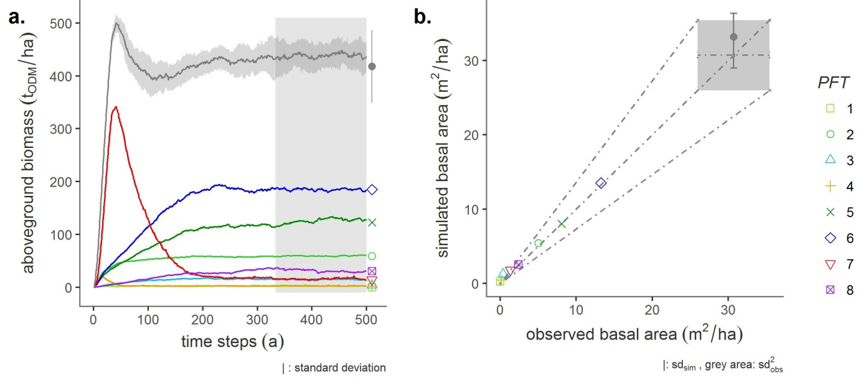

Figure A4: Calibration results. Comparison between the observed (dots) and simulated (line graphs) aboveground biomass development (a.) as well as the mean basal area (b.) for each plant functional type *PFT* and the total stand. Light-demanding pioneers are reddish, shade-tolerant climate species are greenish, emergent are violet, and intermediate species are bluish-colored. During model calibration, only simulation results have been taken into account of the years 333-1000. The simulated attribute values were within the range of the observed variability *sdobs*. Observed standard deviation of the attributes was then projected on the simulation results (grey area).

**Results of model validation:** Figure A5.b shows the temporal development of the aboveground biomass as a secondary succession after 1986. In order to make the time series (observed vs. simulated) comparable, the simulated disturbance event was assigned to the year of the observed disturbance event in 1986. Between 1986 and 2016, the difference between simulated and observed annual mean values of aboveground biomass per *PFT* should be less than the standard deviations *sd* of the observed attribute values. In the period under consideration (1987-2016), the variance of the simulated aboveground biomass deviated only little from the observed attribute values (R2 0.99084, rmse 4.63054). Only for PFT5, the model slightly underestimated biomass in the first years after selective logging until the year 2000. In contrast to the observed attribute values of PFT7 and PFT3 (fast-growing pioneer species), the simulated biomass shows a very short but significant peak (1987-1989). Simulated and observed curves stabilize themselves immediately afterwards.

Furthermore, the model of the Paracou test site estimated the exact number of trees harvested from all commercial tree species. During logging in 1986, around 33.0tODM/ha of aboveground biomass or 10 trees per hectare were harvested on the T1-RIL plots in Paracou. With the simulated harvest of 10 commercially usable trees per hectare and a loss of 33.0tODM biomass per hectare, the model provided a very good estimation of the damage and harvest. In particular, the model reacted sensitively to the parameter daml. In Figure A5.a it is shown that the rates of damage to the remnant forest stand determined from forest inventory data decreases with increasing DBH.

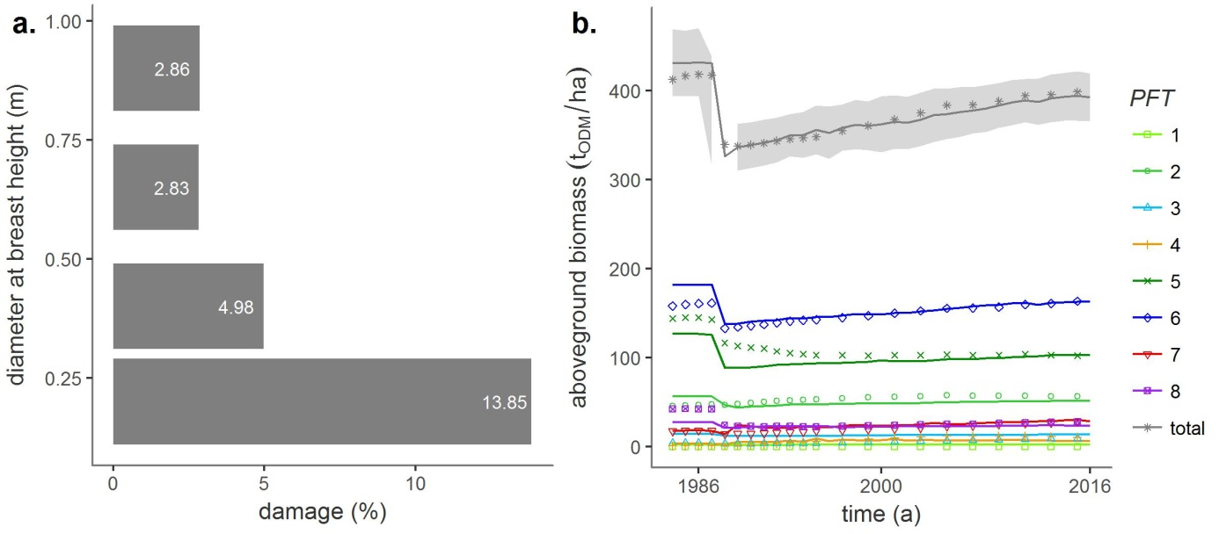

Figure A5: Validation results. a.) The damage to the forest stand of the Paracou test site by man and machine was defined as model parameters, and the values were calculated as a function of four log diameter classes based on forest inventory data of the T1-*RIL* plots. b.) Comparison of the temporal development of observed (dots) and simulated (line graph) aboveground biomass after the selective logging event in 1986 (grey area). Light-demanding pioneers are reddish, shade-tolerant climate species are greenish, emergent are violet, and intermediate species are bluish-colored.

.

**The parameterization** of the FORMIND forest model based on forest inventory data of the study site Paracou in French Guiana. The map in Figure A6 shows the experimental design.

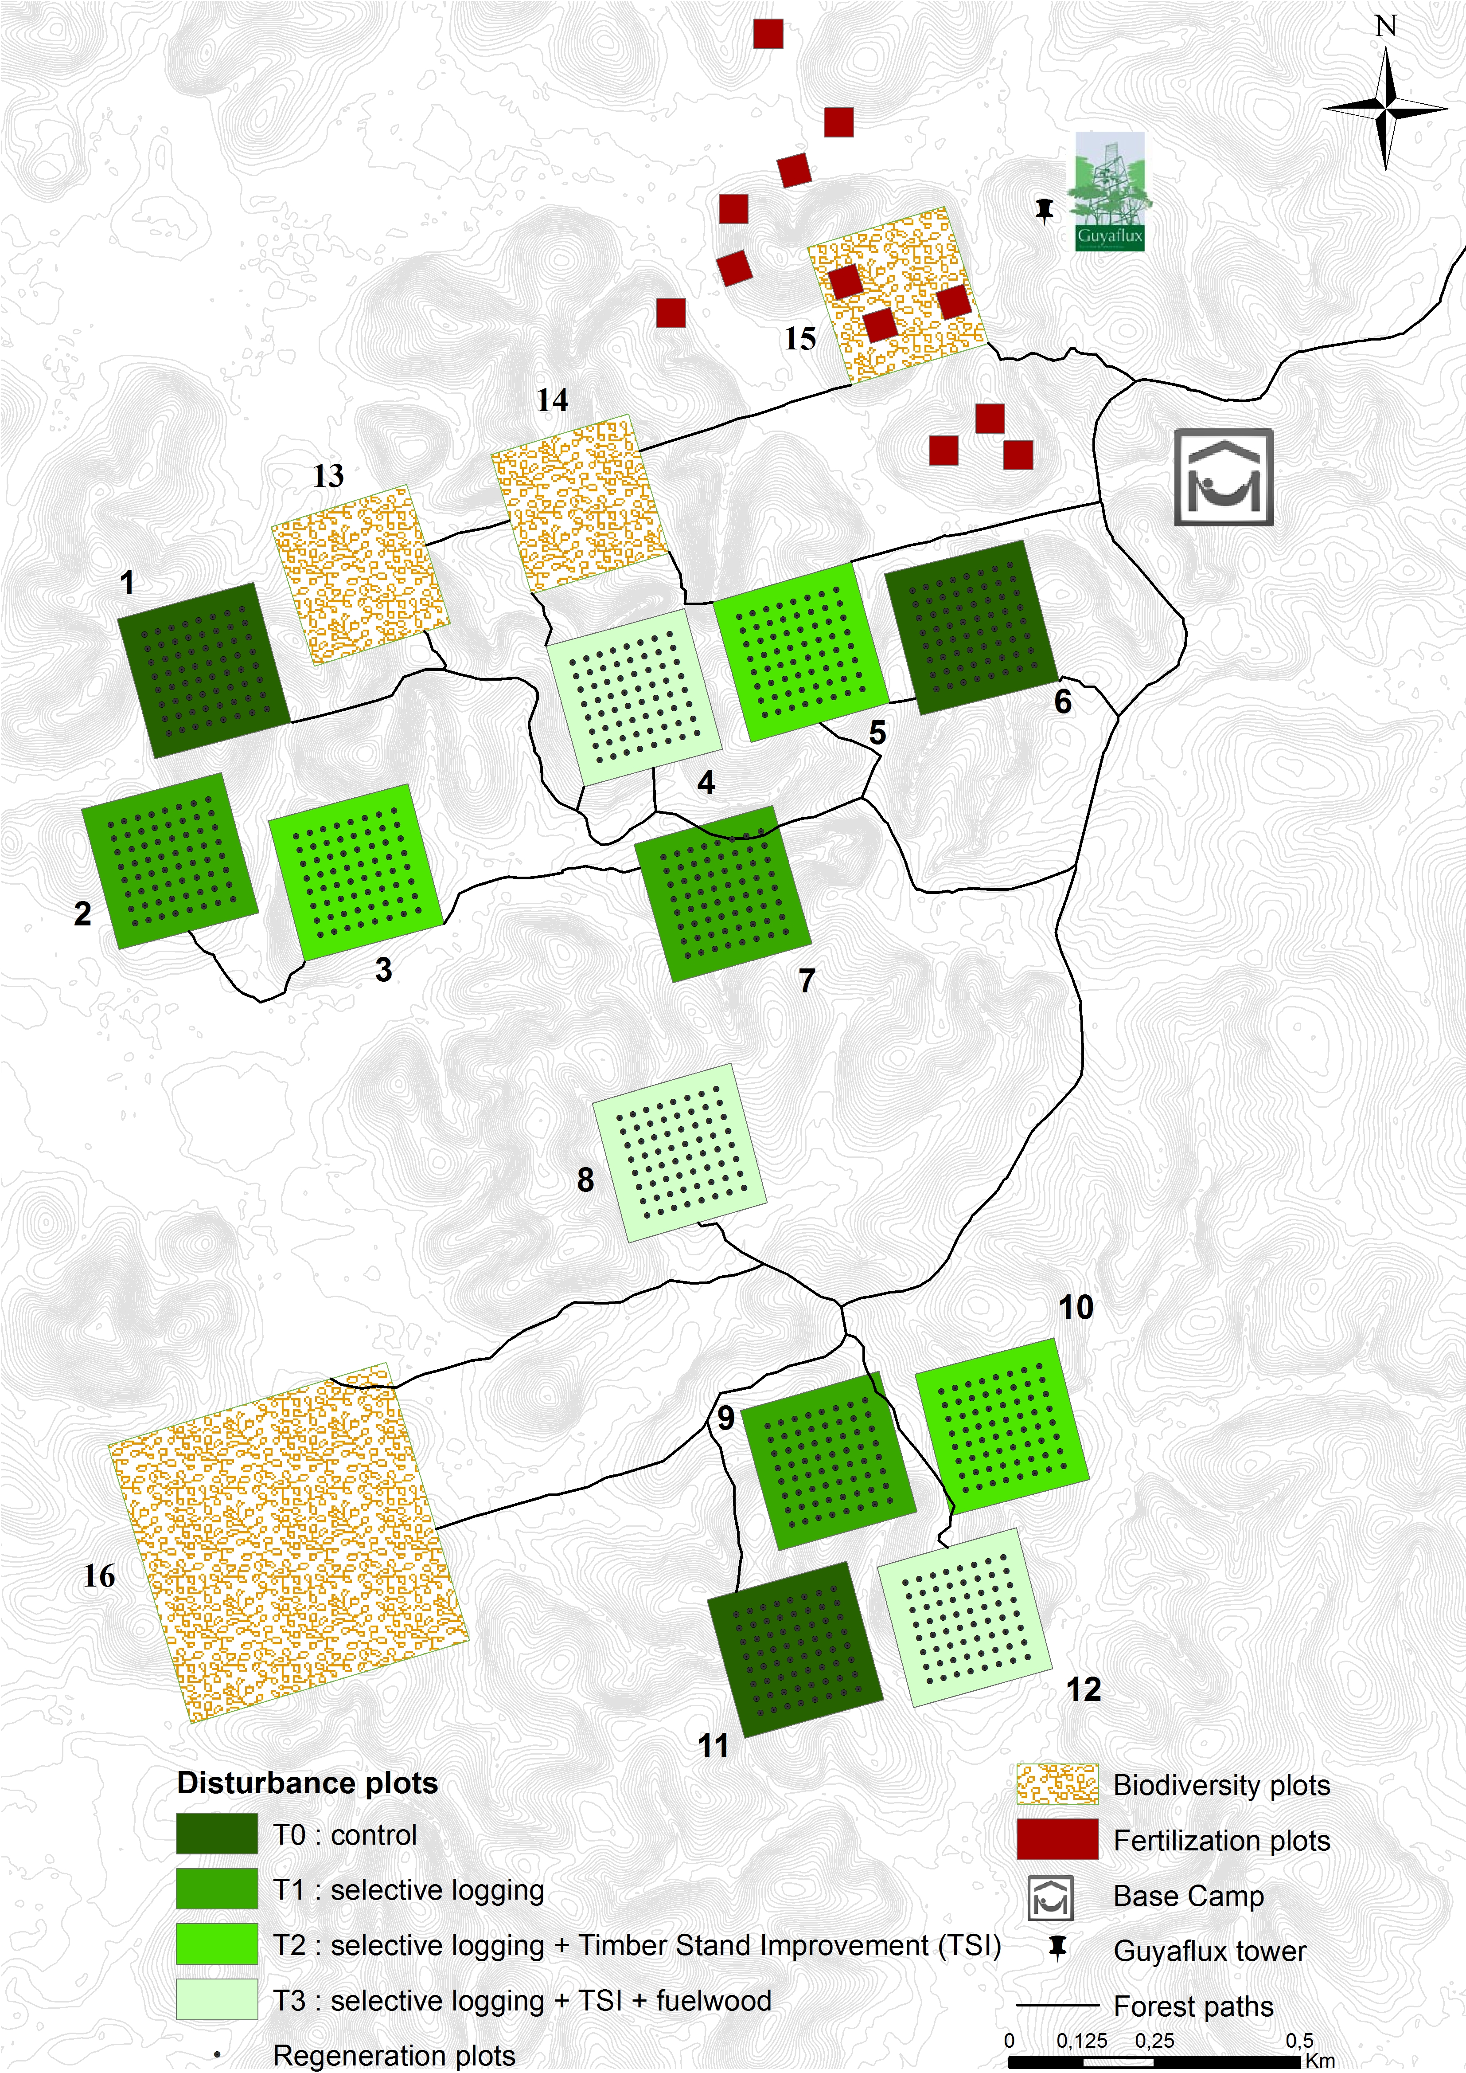

Figure A6: The global map of Paracou's experimental design: To parameterize and calibrate the forest model of FORMIND we used forest inventory data of the T0-control plots and biodiversity plots. The parameterization and validation of FORMIND's management module is based on forest inventory data of the T1-logging plots.

**The correction of *DBH* measurements:** In some cases the normal *DBH* measurement was not possible, so that the measuring point was adjusted according to four rules. The type of rule shows Table A4: Coding for the measuring point of the stem circumference [cm] in Paracou's forest inventory data set.. In order to eliminate bias caused by such an adjustment of the measuring points, a correction of the primary circumferential measurement was calculated, which was used in the course of the study.

Table A4: Coding for the measuring point of the trunk circumference [cm] in Paracou's forest inventory data set.

|  |  |
| --- | --- |
| **Coding** | **Meaning** |
| 0 | normal measure at 1.3 m |
| 1 | elevated measure at 0.5 m |
| 2 | elevated measure at 1.0 m |
| 3 | elevated measure at 1.5 m |
| 4 | tree with irregular stem |

**The types of damage through logging:** It was possible to model logging damages that were defined as the damage to the remaining forest stand. We obtained information about the proportion of damaged trees from the total number of trees; from the inventory data of the T1-*RIL* plots of Paracou (see Figure A6). Table 5 shows the coding of damage through logging.

Table 5: Coding for the type of damage (code measure) and its meaning in Paracou's forest inventory data set. Code alive indicates whether a tree is still alive or not (1: true, 0: false).

|  |  |  |
| --- | --- | --- |
| **Coding alive** | **Coding measure** | **Meaning** |
| 0 | 1 | dead tree, destroyed through overthrow of logged trees |
| 0 | 5 | dead tree, destroyed through man and machine |
| 0 | 8 | dead tree, destroyed after exploitation |

In FORMIND the parameter *dam1* was calculated as fraction of the sum of counted stems *n* of dead trees through logging and all trees on the T1-*RIL*-plots *nt*, with the indices indicating the type of damage *code alive|code measure*:

$dam dia =(n_{0|1}+n_{0|5}+n_{0|8})/n_{t}$.

# Appendix A2

**Software used:** To process the data of Paracou's forest inventories as well as the simulation results of FORMIND v3.1 (Fischer et al., 2016), version 3.4.3 of the R statistical software (R Core Team, 2017) with the packages 'tidyverse' v1.2.1 (Wickham, 2017a), 'modelr' v0.1.1 (Wickham, 2017b), 'splines' (R Core Team, 2017), 'bookdown' v.0.5 (Xie, 2017) were used. MOOP v0.21 was used (Lehmann and Huth, 2015) during the fine-tuning of the FORMIND forest model.

# References

Chave, J., Coomes, D., Jansen, S., Lewis, S.L., Swenson, N.G., Zanne, A.E., 2009. Towards a worldwide wood economics spectrum. Ecol. Lett. 12, 351–366. https://doi.org/10.1111/j.1461-0248.2009.01285.x

Fischer, R., Armstrong, A., Shugart, H.H., Huth, A., 2014. Simulating the impacts of reduced rainfall on carbon stocks and net ecosystem exchange in a tropical forest. Environ. Model. Softw. 52, 200–206. https://doi.org/10.1016/j.envsoft.2013.10.026

Fischer, R., Bohn, F., Dantas de Paula, M., Dislich, C., Groeneveld, J., Gutiérrez, A.G., Kazmierczak, M., Knapp, N., Lehmann, S., Paulick, S., Pütz, S., Rödig, E., Taubert, F., Köhler, P., Huth, A., 2016. Lessons learned from applying a forest gap model to understand ecosystem and carbon dynamics of complex tropical forests. Ecol. Modell. 326, 124–133. https://doi.org/10.1016/j.ecolmodel.2015.11.018

Hiltner, U., Bräuning, A., Gebrekirstos, A., Huth, A., Fischer, R., 2016. Impacts of precipitation variability on the dynamics of a dry tropical montane forest. Ecol. Modell. 320, 92–101. https://doi.org/10.1016/j.ecolmodel.2015.09.021

Jucker, T., Caspersen, J., Chave, J., Antin, C., Barbier, N., Bongers, F., Dalponte, M., van Ewijk, K.Y., Forrester, D.I., Haeni, M., Higgins, S.I., Holdaway, R.J., Iida, Y., Lorimer, C., Marshall, P.L., Momo, S., Moncrieff, G.R., Ploton, P., Poorter, L., Rahman, K.A., Schlund, M., Sonké, B., Sterck, F.J., Trugman, A.T., Usoltsev, V.A., Vanderwel, M.C., Waldner, P., Wedeux, B.M.M., Wirth, C., Wöll, H., Woods, M., Xiang, W., Zimmermann, N.E., Coomes, D.A., 2017. Allometric equations for integrating remote sensing imagery into forest monitoring programmes. Glob. Chang. Biol. 23, 177–190. https://doi.org/10.1111/gcb.13388

Köhler, P., Chave, J., Riéra, B., Huth, A., 2003. Simulating the long-term response of tropical wet forests to fragmentation. Ecosystems 6, 114–128. https://doi.org/10.1007/s10021-002-0121-9

Larcher, W., 1994. Ökophysiologie der Pflanzen. UTB 394.

Lehmann, S., Huth, A., 2015. Fast calibration of a dynamic vegetation model with minimum observation data. Ecol. Modell. 301, 98–105. https://doi.org/10.1016/j.ecolmodel.2015.01.013

Molto, Q., Hérault, B., Boreux, J.-J., Daullet, M., Rousteau, A., Rossi, V., 2014a. Predicting tree heights for biomass estimates in tropical forests &amp;ndash; a test from French Guiana. Biogeosciences 11, 3121–3130. https://doi.org/10.5194/bg-11-3121-2014

Molto, Q., Hérault, B., Boreux, J.J., Daullet, M., Rousteau, A., Rossi, V., 2014b. Supplement of: Predicting tree heights for biomass estimates in tropical forests -A test from French Guiana. Biogeosciences 11, 3121–3130. https://doi.org/10.5194/bg-11-3121-2014

R Core Team, 2017. R Development Core Team. R A Lang. Environ. Stat. Comput. https://doi.org/http://www.R-project.org

Rutishauser, E., Wagner, F., Herault, B., Nicolini, E.-A., Blanc, L., 2010. Contrasting above-ground biomass balance in a Neotropical rain forest. J. Veg. Sci. 21, 672–682. https://doi.org/10.1111/j.1654-1103.2010.01175.x

Wickham, H., 2017a. tidyverse: Easily Install and Load the “Tidyverse.”

Wickham, H., 2017b. modelr: Modelling Functions that Work with the Pipe.

Xie, Y., 2017. bookdown: Authoring Books and Technical Documents with R Markdown.

Zanne, A.E., Lopez-Gonzalez, G., Coomes, D.A.A., Ilic, J., Jansen, S., Lewis, S.L.S.L., Miller, R.B.B., Swenson, N.G.G., Wiemann, M.C.C., Chave, J., 2009. Data from: Towards a worldwide wood economics spectrum. Dryad Digital Repository., Dryad. https://doi.org/10.5061/dryad.234